Accuracy Measures

Accuracy of a classifier is measured simply by checking correct to total outputs. However this may not always be the best way to test a model because accuracy is a measure of TP+TN/(TP+TN+FP+FN) however this can only be valid when there all classes in the dataset has almost same number of entries. Thus need to find other reliable measure arise. And so we look for

Precession
Recall
F1 Score

Let’s walk through the whole process in brief.

Once a model has been trained it must be seen how good a model is and naturally what metric comes to mind is accuracy. So to find the accuracy we look at confusion matrix.

Input

In the confusion matrix above we see that there were 6 dogs in total in our dataset while our model predicted that there are three dogs and three of the other six were classified as cats, and 2 cats were incorrectly classified as dogs out of six cats in total.

Let’s look at a bigger example
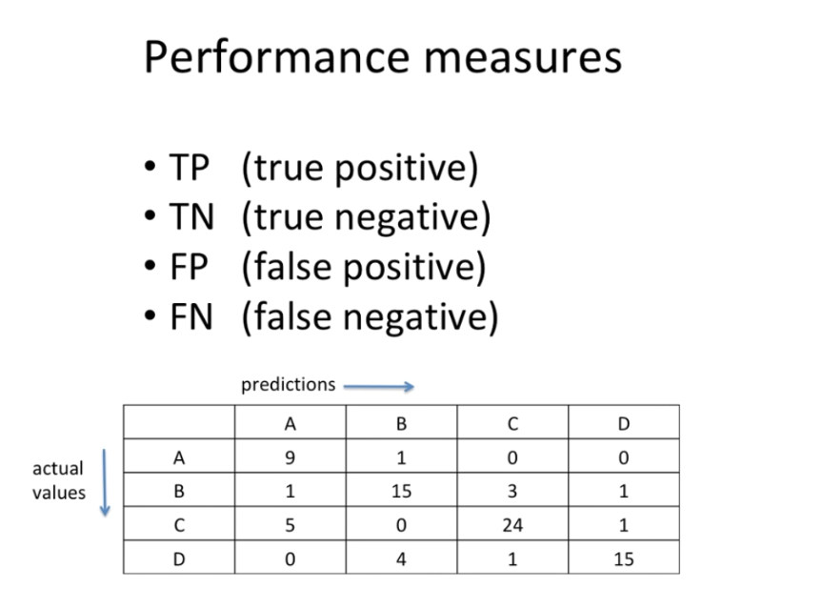

Here we have four classes “A”, “B”, “C” and “D”.
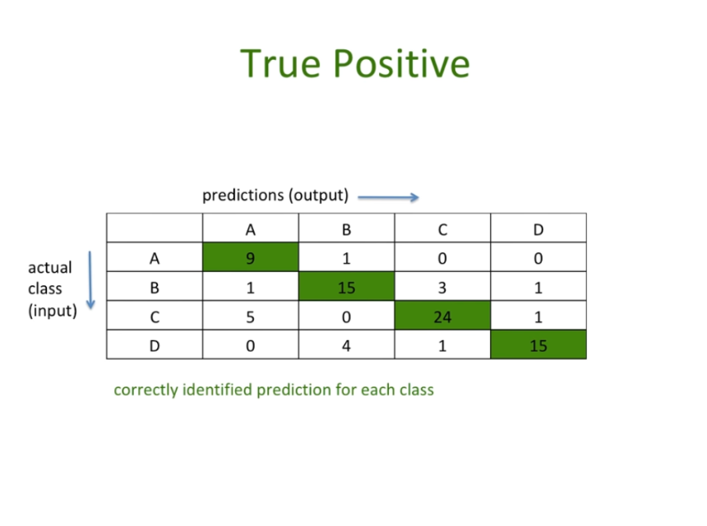

Here we we can see the green diagonal depicts the true positive across all classes. However if we are to take true negatives, that would be only for a single class and is depicted below.

Similarly true negative for another class say “D” would be like this, below.
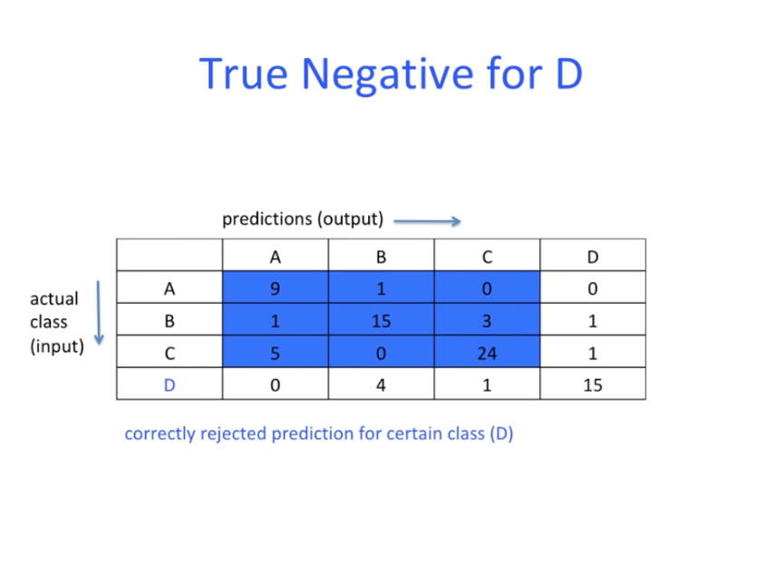

Same way we can find the false positive for a given class.
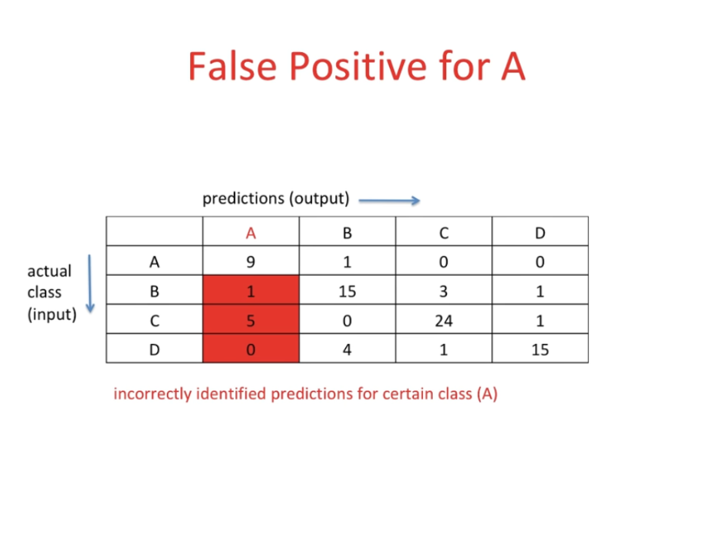

And finding false positive for another class is easy as picture below.

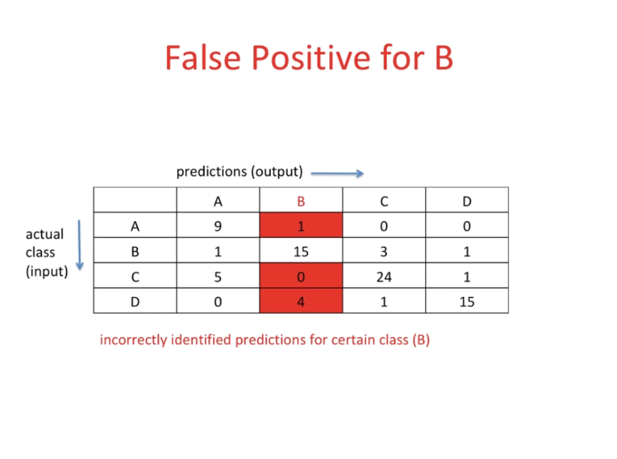

False negative is not much difficult either to determine for a given class.
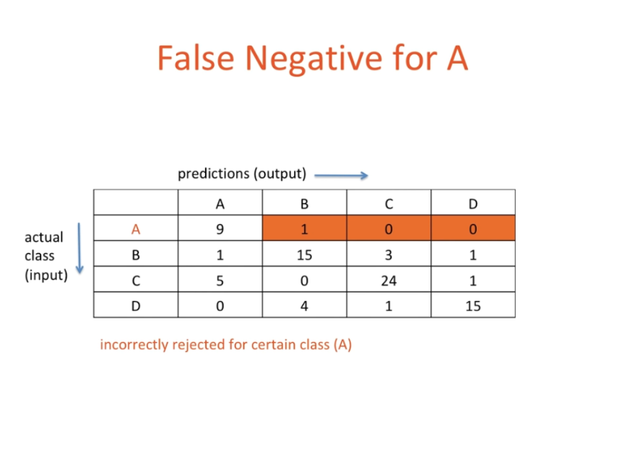

This way accuracy would be total number of true values divided by total entries in the dataset.
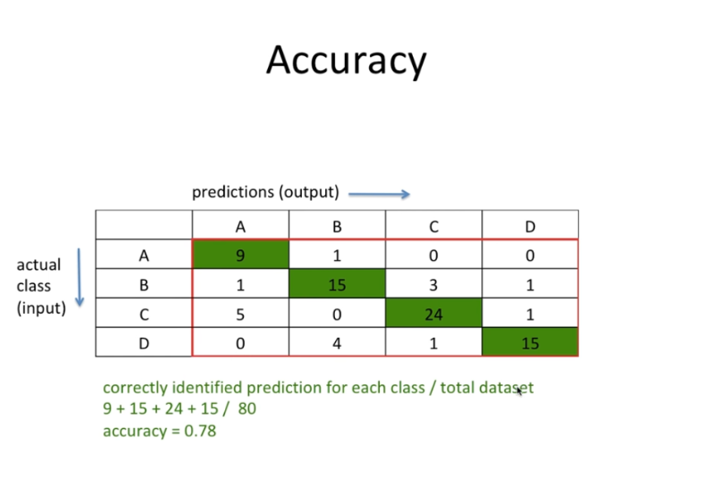

However if data is not balanced then accuracy might be high and yet that result of the model may not be valid. Let’s see this through this example.

There are a hundred dogs in a dataset and only two cats. And the model predicted all the images as dogs, thus accuracy would be 100/102 that is almost 98% accuracy rate however, model failed to predict cats completely, which means it just missed a whole class yet it is “very accurate”. If cats and dogs classification is not much to you, then consider patients of skin cancer and lung cancer. Treatment for which would be totally different in both cases, however if all the patients were treated the same way then possibility of the wrongly classified patient's survival would be very wrong. Similarly in other mission critical situations simple accuracy is not always considered the good metric for validation of a model. Let’s look at precision and recall now.

Precision

To combat these problems we arrive at precision.

Out of total number of patients predicted as lung cancer how many were actually suffering from lung cancer. Algebraically it would be
Precision = TP/TP+FP

Recall

Precision is a great metric however alone it can’t be just the way to go, because consider this example where you have high precision since you do not have many false positives in the prediction yet the model has left out many of the patients who were actually in critical situation. This would be very bad. So we still need to find a way to identify a metric which would alarm if we miss some patients, so we arrive at recall. Which is defined as below.
Out of total number of actual lung cancer how many were correctly identified and this would be represented as
Recall = TP/TP+FN

F1 Score

These both metrics are good and usually used with accuracy however there might still be some situations where merely using only recall or precision might not be good idea, so the best thing that comes to mind is to combine them.

The weighted average or simple harmonic mean of the above two metrics is F1 score.
F1 Score = 2*(Recall * Precision) / (Recall + Precision)
